**Week 1 Project Work**

**Step 1** : Open the **Power BI Desktop**.

Then click on the **Blank report .**

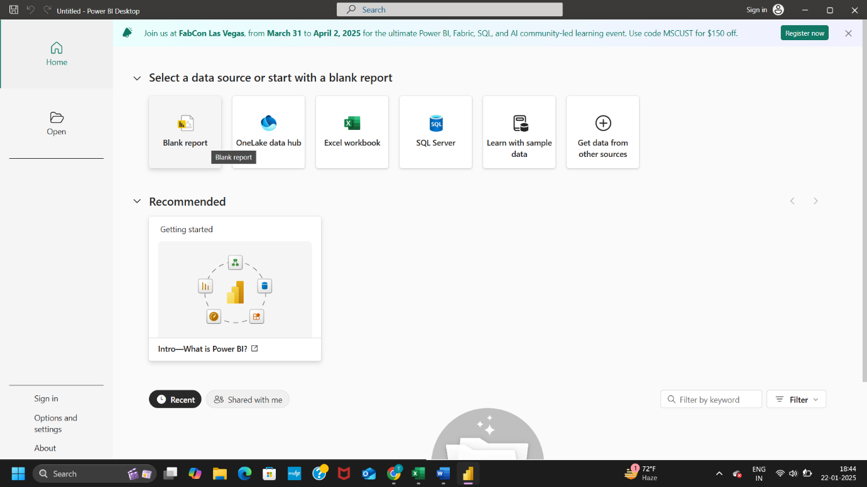

**Step 2** : On the top in **Home** tab , **Get data** option is visible then click on the **Get data** and multiple options are visible on your screen then select the option according to which type of file you will inserted (i.e. , Excel Workbook, Text/CSV, XML ,Json and etc.) and then click on the **Connect** button and choose the file and click Open button.

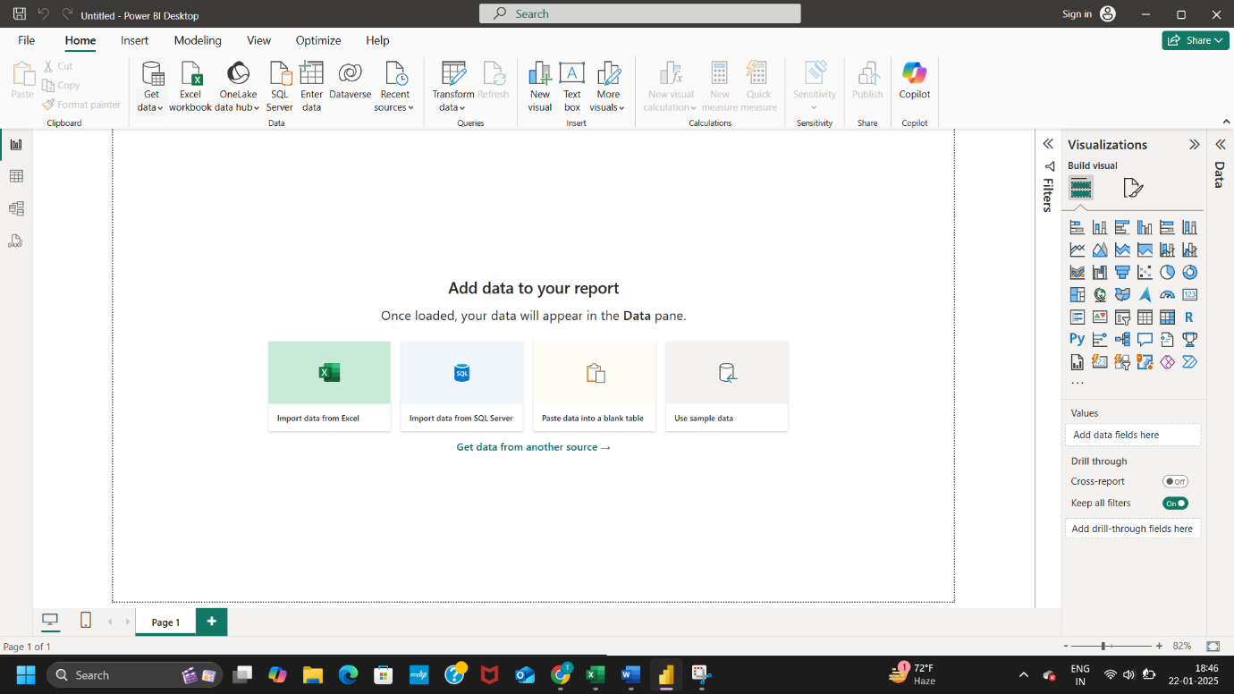

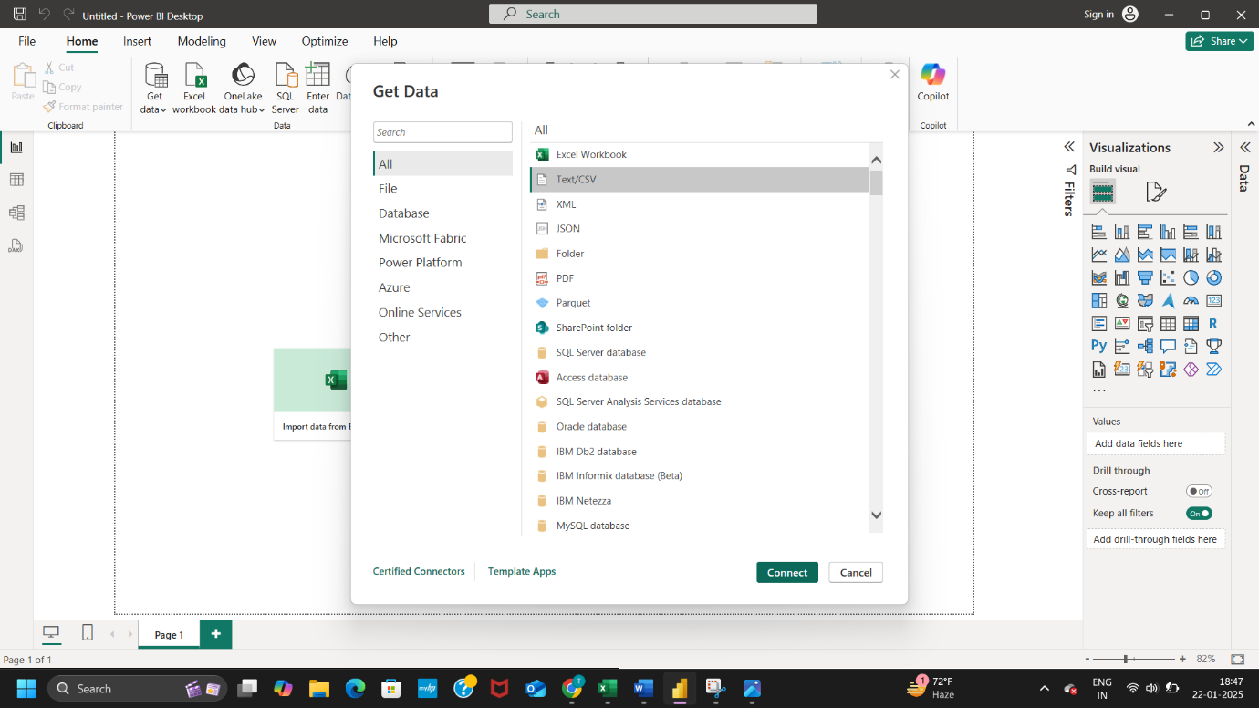

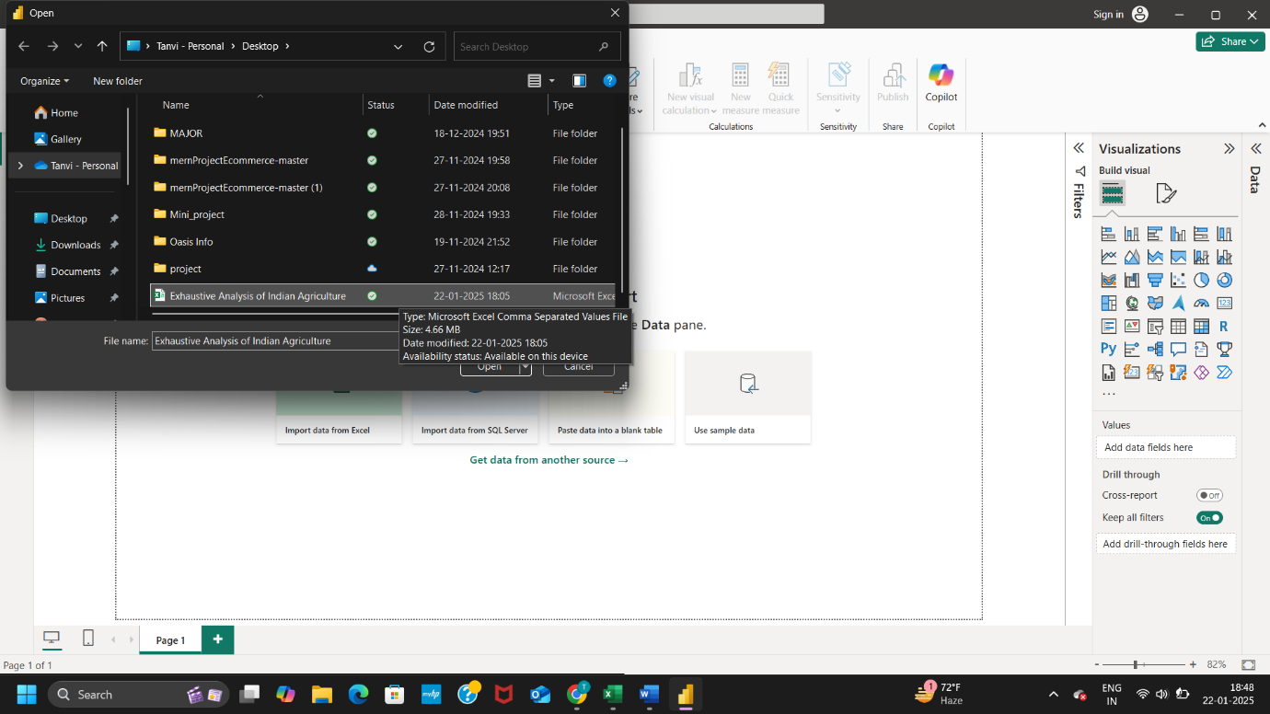

**Step 3** : File is open then an interface according to your file represented and three button showing you :

1. Load – When your data is cleaned , you can simply use Load button but unfortunately you click on the Load button , so not occured any problem.

2. Transform Data – When you want to process the data then you click on the Transform Data button.

3. Cancel

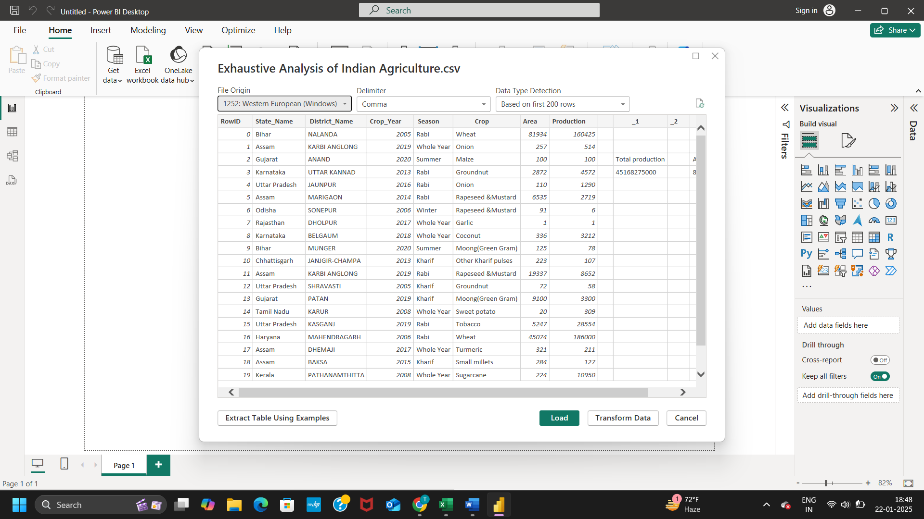

**Step 4** : When you are not transform data in the previous step 3 then the menu bar transform data option is visible click it and two option are coming : 1. Transform data

2. Data source setting ,

Then click on Transform data . Take some time to transform the data.

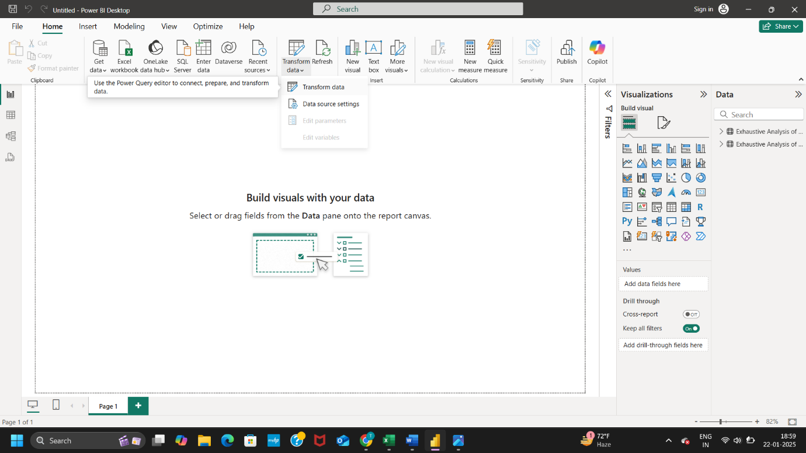

**Step 5** : Two window file open in Power BI Desktop :

1. Power BI Desktop
2. Power Query Editor

* In Power Query Editor , transform file visible to you then you have unnecessary columns then delete it ( **tap to column + right click , then click on remove**).

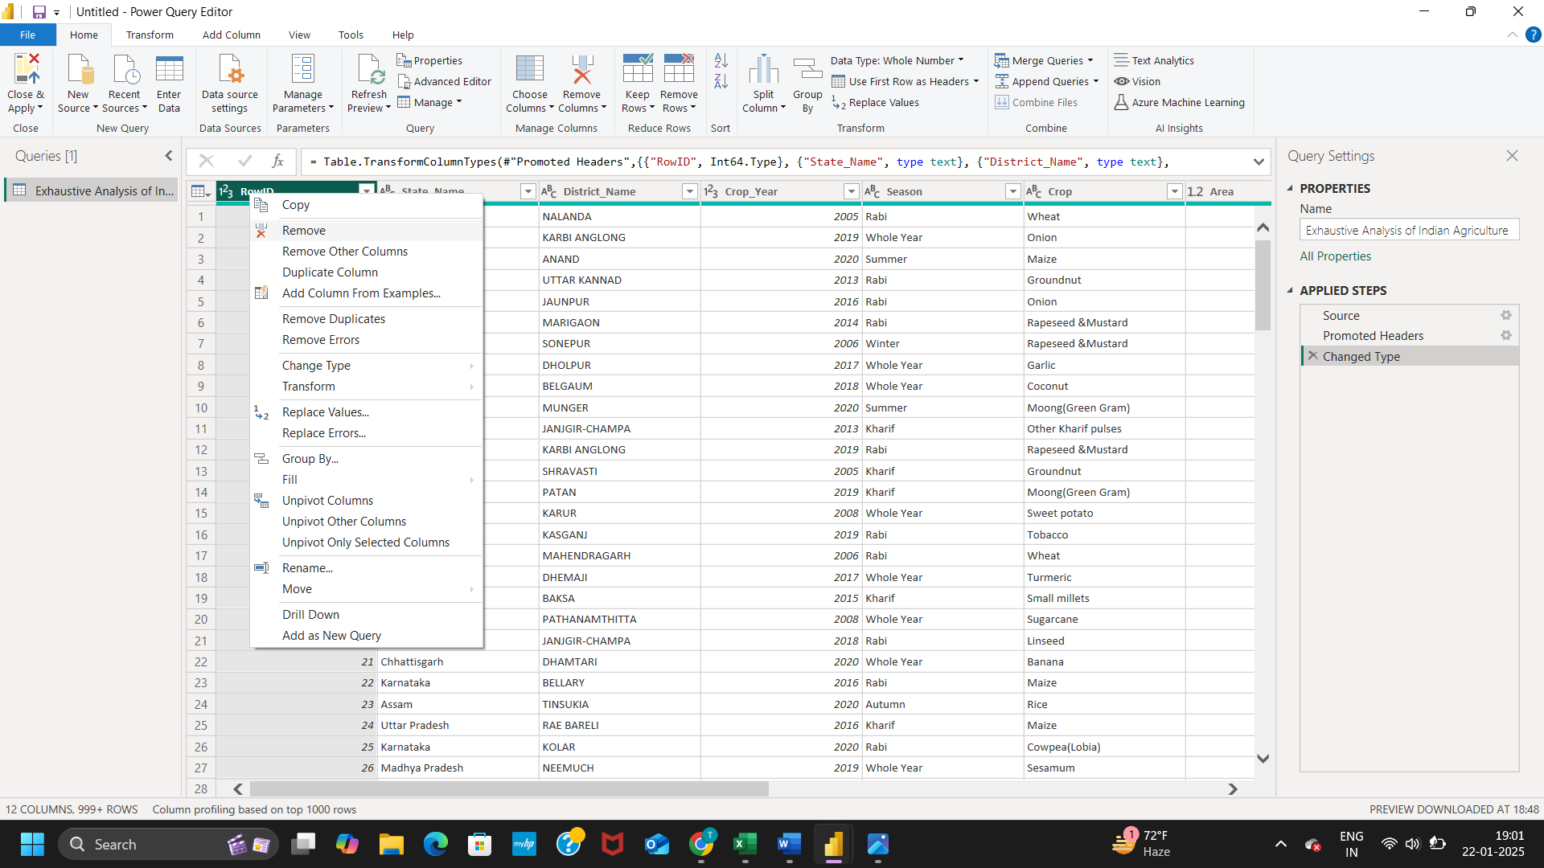

* You retrieve the columns then you click on the **remove button available right side of applied steps .**
* In the top menu bar , **Keep Rows and Remove Rows** , you easily retrieve and remove the rows.
* In the title bar , View , click on it then check the **Column quality box** and Valid , Error and Empty column shows top of the all columns , and easily check the valid data , error in the data and any empty or null value .

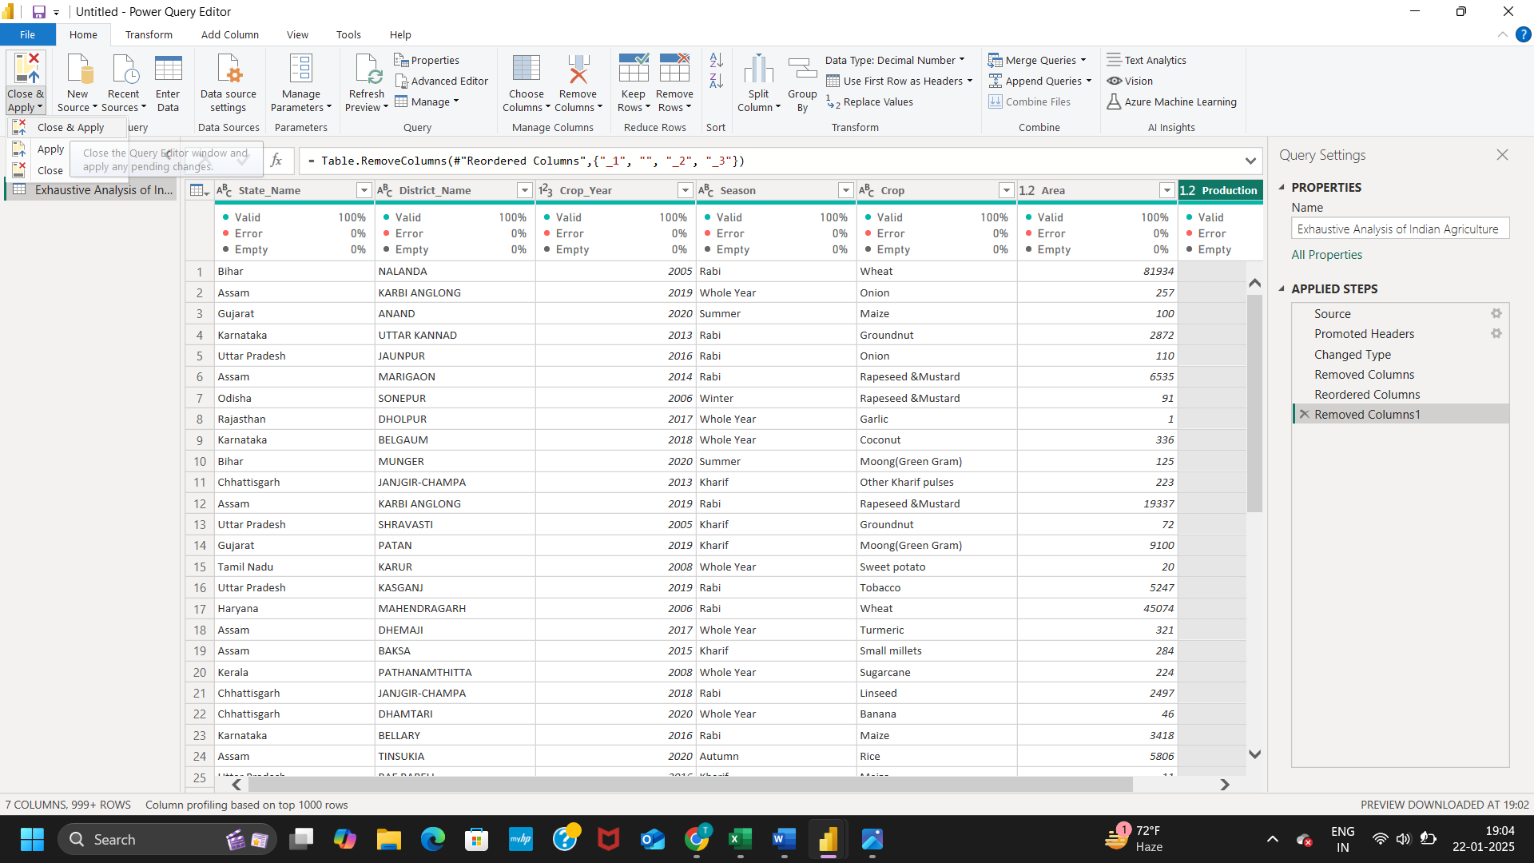

Step 6 : Click on the **Close & Apply** and then again shows three option and click on the **Close & Apply** option (close the query editor window and apply any pending changes).

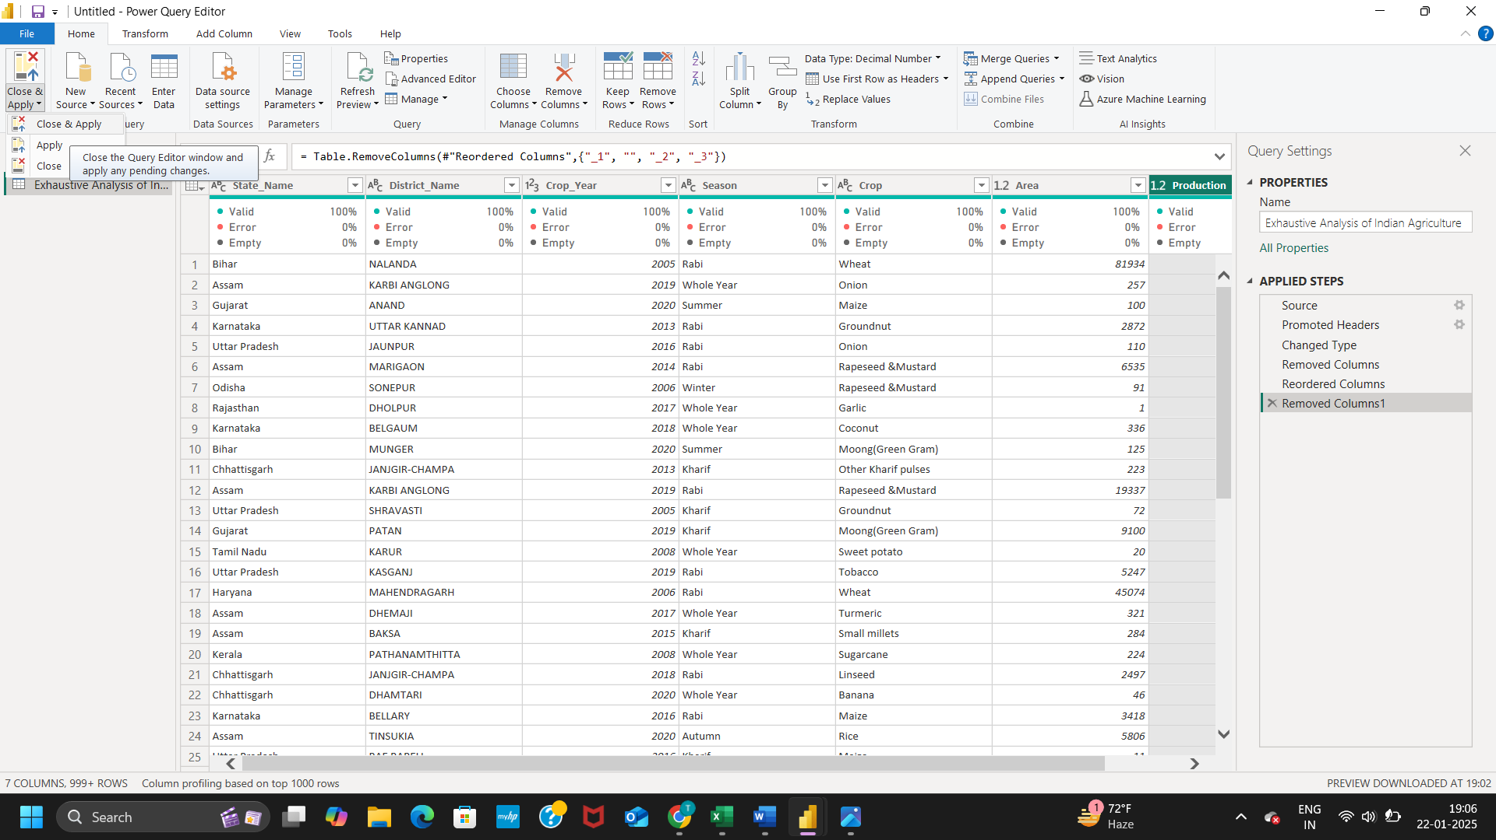

In Power BI Desktop , three type of views :

1. Report View – For visualization of data.
2. Table view – See the data in the table format.
3. Model View – Here we can create relationship among data and also visualize it.